YILDIZ TEKNİK ÜNİVERSİTESİ
YILDIZ TECHNICAL UNIVERSITY
TR ISTANBU07

WELCOME GUIDE for TRAINEESHIP MOBILITY
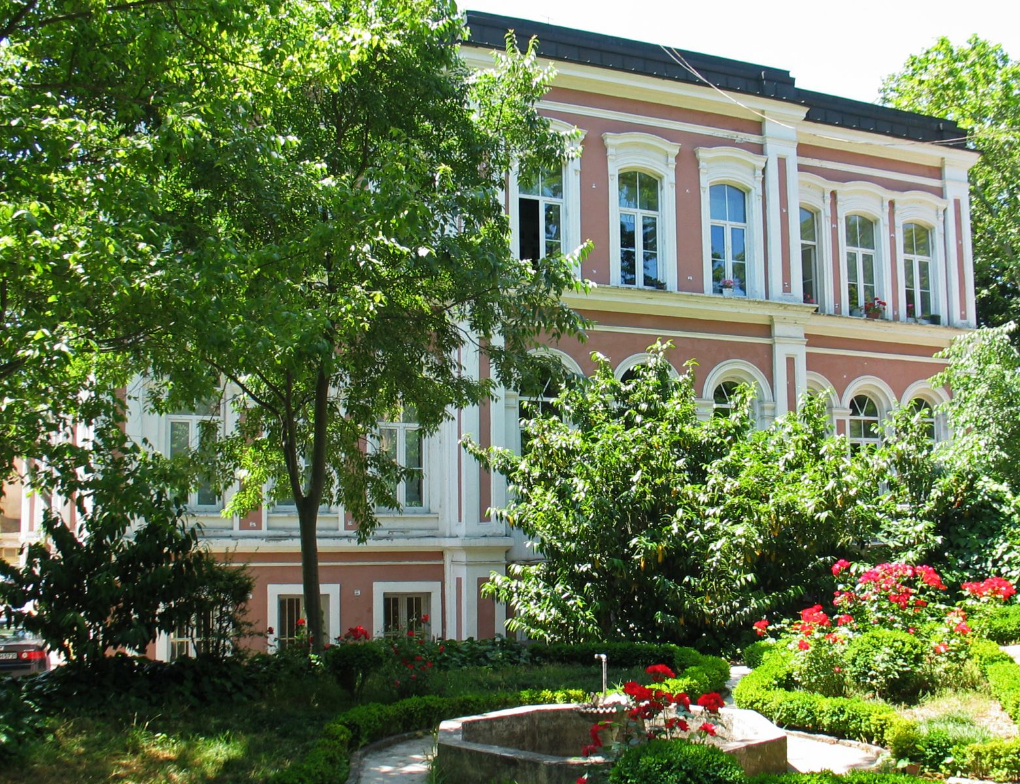

Contents
A. Welcome 3
1- İstanbul 4
2- Yıldız Teknik Üniversitesi (YTU) 5
3- YILDIZ-TÖMER 6
4- Erasmus Student Network (ESN) YTU: 6
B. Arrival in Istanbul 7
1. Residence Permit 8
2. Student ID Card 10
3. Transportation 10
4. Museum Card (Müzekart) 10
5. Weather/Clothing 11
6. Shopping Places/Hours 11
8. Cultural Activities 12
9. Miscellaneous Costs 12
C. Academic Issues 12
1- Before the Mobility 12
2- During the Mobility 13
3- After Mobility 13
D. Reminders 13
E. EU Office Hours 14
F. Useful links 14
G. Useful numbers 14

A. Welcome
Dear Students,
It is a pleasure for us to be able to welcome you at YTU for your mobility programme. We all hope that your Erasmus period at YTU will be a unique adventure in your life and it makes an outstanding contribution to your life in terms of both academic and social aspects.
The number of international students incoming to YTU is increasing each year, which adds greatly to the multicultural environment on campus. In this respect, we would like to host you here with your cultural background, which will enrich the international atmosphere on campus.
Please, read the Welcome Information Guide carefully, which includes invaluable information for a foreigner. We hope this guide will give you full awareness about living and studying at YTU.
You are more than welcome at YTU and EU Office to ask any questions you may have or consult in any matter, where you will always find a friendly face.
All the best from EU Office Staff
Phone: +90 212 383 56 55
Fax: +90 212 383 56 56
Web: www.eu.yildiz.edu.tr
E-mail: erasmus-staj@yildiz.edu.tr
Address: Yıldız Teknik Üniversitesi, Avrupa Birliği Ofisi
Davutpaşa Kampüsü, Taşkışla Binası A-1003
34220 Esenler / İSTANBUL TURKEY

İstanbul
Located in the centre of the Old World, Istanbul is one of the world's great cities famous for its historical monuments and magnificent scenic beauties. It is the only city in the world which spreads over two continents: it lies at a point where Asia and Europe are separated by a narrow strait - the Bosphorus. Istanbul has a history of over 2,500 years, and ever since its establishment on this strategic junction of lands and seas, the city has been a crucial trade centre.
The historic city of Istanbul is situated on a peninsula flanked on three sides by the Sea of Marmara, the Bosphorus and the Golden Horn. It has been the capital of three great empires, the Roman, Byzantine and Ottoman empires, and for more than 1,600 years over 120 emperors and sultans ruled the world from here. No other city in the world can claim such a distinction. During its development, the city was enlarged four times, each time the city walls being rebuilt further to the west.
Surrounded by 5th century Roman city walls and stretching over seven hills, Istanbul is adorned by the masterpieces of Turkish art, the great mosques of the Sultans that crown the hills. The city presents an exquisite, majestic and serene silhouette from all directions. The Golden Horn, which is a very secure natural harbour, has played a significant role in the development of the city.
Fortune provided such advantages to Istanbul as a location at a junction where the main overland routes reach the sea, an easily defensible peninsula, an ideal climate, a rich and generous nature, control of the strategic Bosphorus, and a central geographical position in the ancient world.
As a capital of empires, the city was not only an administrative, but also a religious centre. The Patriarchate of Eastern Christians has been headquartered here since its establishment, and the largest early churches and monasteries of the Christian world rose in this city on top of the pagan temples. Within a century after the city was conquered, it was enriched with mosques, palaces, schools, baths and other architectural monuments that gave it a Turkish character, while some of the existing churches in ruins were repaired, altered and converted into mosques. Between the 16th century when the Ottoman sultans acquired themselves the title of the "Caliph of Islam" and 1924, the first year of the Republic, Istanbul was also the headquarters of the Caliphate. More Jews settled in Istanbul than any other port, and here they built themselves a new and happy life after they were rescued from Spain by the Turks in the 15th century. Istanbul has always been a city of tolerance where mosques, churches and synagogues existed side by side. The city was adorned with a large number of dazzling and impressive works even during the period of decline of the Ottomans.
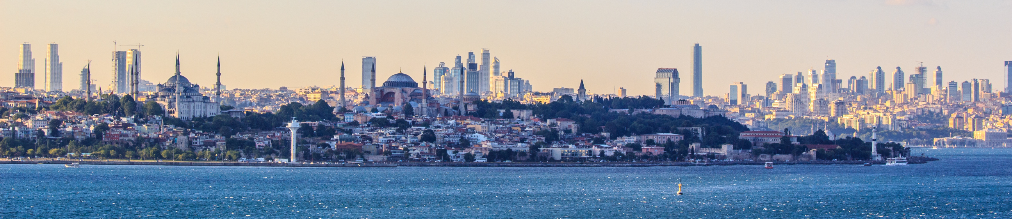During this time, the influence of European art made itself felt in the new palaces, while the northern slopes of the Golden Horn, Galata and Beyoğlu districts assumed a European character. Even when the Empire, which was a party to World War I, collapsed and the young Republic that replaced it moved the capital to Ankara, Istanbul did not lose its significance.
In the 1970s, Istanbul’s population rapidly increased, causing the city to expand into the nearby villages and forests, eventually creating a major world metropolis. Today its population is over 14 million and still increases constantly. It continues to be the commercial and cultural centre of Turkey.
Istanbul's many historical areas were added to the UNESCO World Heritage list in 1985. In addition, because of its status as a world rising power, its history, importance to culture in both Europe and the world, Istanbul has been designated the European Capital of Culture for 2010 by the European Union.

Yıldız Teknik Üniversitesi (YTU)
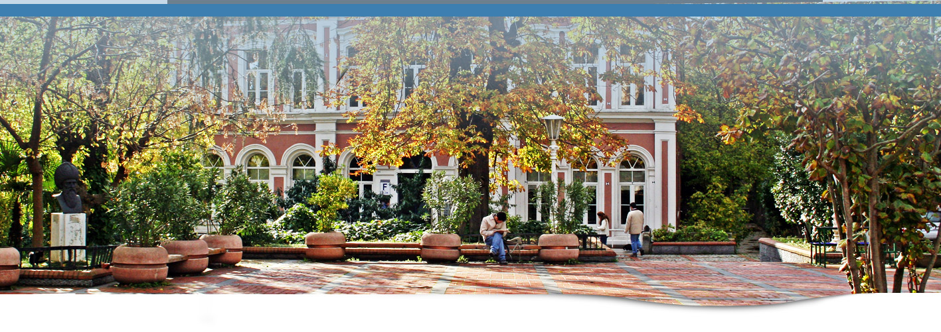
Since being founded in 1911 Yıldız Technical University has been a beacon for knowledge in the technical field. It has since been evolving for both country and the city. Since starting as a major engineering school, it has been increasingly becoming a major center for knowledge with highly professional staff and many learning activities. The university’s mission has been stated as “Our mission is to create a university which pioneers education, scientific research, technological development and artistic work aimed at the progress of society and the increase of the quality of life within an understanding of national and international solidarity; and educates creative, enterprising, questioning and ethical students equipped with universal values, who constantly renew themselves, aim for lifelong learning and are capable of analysis and synthesis.”
Currently Yıldız Technical University has three campuses Yıldız Central Campus, Maslak Campus, Davutpaşa Campus.
List of Faculties:
Yıldız Campus | Davutpaşa Campus | Maslak Campus
Economics and Administrative Sciences | Electrical and Electronic Engineering | School of Vocational Studies
Mechanical Engineering | Education
Architecture | Science and Letters
Naval Architecture and Maritime | Civil Engineering
Vocational School of National Palaces and Historical Buildings | Chemical and Metallurgical Engineering
Graduate Schools | Art and Design
 | School of Foreign Languages

Libraries are accessible to all students with their student ID. The main library is located in Davutpaşa Campus. Main library is home to our university’s ever growing collection. It has five floors and capable of holding over 600 people. There is another library at Yıldız Campus, as well.

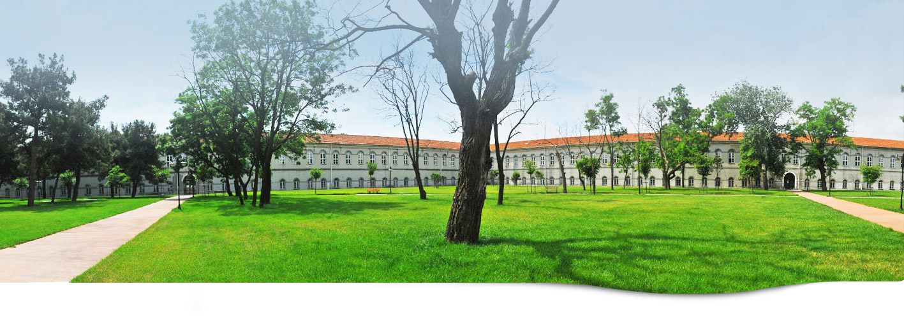
In order to enable the students to be integrated with each other at the faculties and departments, and to grant them with the competition excitement, competitions are organized between the Faculties in the fields of Basketball, Table Tennis and Volleyball; and moreover course programmes are provided in various sport fields such as Aerobics, Badminton, Bowling, Dance, Folk Dance, Korfball, Taekwondo, Tennis and Volleyball.
Yıldız Campus | Davutpaşa Campus | Ayazağa Campus
1 Basketball Field (Outdoor) | 1 Multi-functional Sport Saloon  1 Fitness Saloon  2 Tennis Court  3 Basketball Field (Outdoor)  1 Swimming Pool (Outdoor)  1 Swimming Pool (Indoor) | 2 Indoor Saloons (Non-standard)  1 Football pitch (Mini)  4 Wrestling Saloon  1 Table Tennis Saloon

YILDIZ-TÖMER
It is the institution, located in Yıldız campus, providing Turkish language instruction to all individuals who have chosen Turkish as their medium of communication for academic or professional pursuits which will enable them to achieve personal, academic and career success, and to promote international and intercultural understanding.
You can contact TÖMER for any administrative issues: application, acceptance, lectures, information etc.

Phone: +90 212 383 23 60
Fax: +90 212 383 23 59
Web: www.tomer.yildiz.edu.tr
E-mail: tomer@yildiz.edu.tr
Address: Barbaros Bulvarı 34349 Yıldız-İstanbul

Erasmus Student Network (ESN) YTU:
YTU is a member of ESN (Erasmus Student Network) and ESN YTU will help out incoming students in social matters: City guide, accommodation, transportation, student facilities, student events, etc.
Web: www.ytu.esnturkey.org
E-mail: esnytu@esnturkiye.org
facebook.com/yildizerasmussociety
twitter.com/esnytu
instagram.com/esnytu
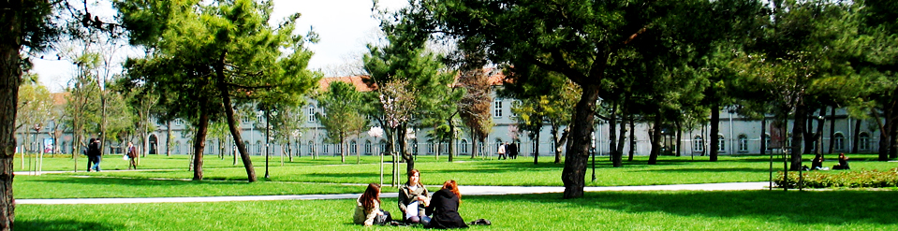

B. Arrival in Istanbul
There are currently two airports in Istanbul; Atatürk Airport (on European Side) and Sabiha Gökçen Airport (on Anatolian Side). Most of the international flights take place at Atatürk Airport.
Please remember there are many transportation alternative in Istanbul. The below choices are done so as not to change many vehicles. If you want to get to your destination quicker, you may prefer to use more vehicles
To get to the city from the airports to a few central areas;
From Atatürk Airport to Taksim | Subway; situated exactly below the airport
 | Taxi; opposite to the exit door
Havataş (shuttle); opposite to the exit door
Timetable: http://www.havatas.com/
From Atatürk Airport to Besiktas | You can take taxi directly or after you get to Taksim take a local bus.
From Atatürk Airport to Kadıköy | You can take taxi directly or after you get to Taksim take a local bus.  Another way is to get to Bakırköy first (10 min. taxi run) and take the ferry to Kadıköy.
From Sabiha Gokcen to Kadıköy | Local Bus; opposite to the exit door  No: E-10 or E-11  Another way is to get to Kartal first and take the metro to Kadıköy.  Timetable: http://www.iett.gov.tr/en
 | Taxi; opposite to the exit door
Havataş; opposite to the exit door
Timetable: http://www.havatas.com/
From Sabiha Gokcen to Besiktas | You can take taxi directly or after you get to Kadıköy take a local bus or boat.
From Sabiha Gokcen to Taksim | You can take taxi directly or after you get to Kadıköy take a local bus.  Another way is to get to Karaköy first by boat from Kadıköy and take a bus or minibus.
Before starting to online application for residence permit, please:
- Read this guide and the notifications carefully,
- Make sure that there is a printer connected to the computer since you have to print out the online application document,
- Provide passport photo in a .jpeg format to upload to the online application system (not bigger than 500 kb)
- Provide a telephone number from an operator in Turkey since the system will send SMS for notifications when your residence permit card is prepared or if there is a problem (you may request your buddy to use his/her telephone number if you do not have one yet)
!!! Remember that this document is prepared only for information. Thus, students have to follow the procedures as explained on www.e-ikamet.goc.gov.tr .

Residence Permit
If your stay will be more than 90 days, you need to apply for residence permit within 30 days after your arrival by following the steps below;

- Go online to complete your e-residence application within 30 days after your arrival.
The date of your application is important for declaring the duration of your stay in Turkey. Thus, do not feel stressed if the system gives you an appointment date later than that 30-day period.

Application link: https://e-ikamet.goc.gov.tr/

- Choose “First Application” if you do not have a residence permit.
- Read the explanations and make sure that you have all requirements and confirm the verification number that is sent to either your Turkish mobile number or valid e-mail address.
- Choose the type of residence permit you will apply.
- Choose “Istanbul” as the province for the residence permit.
- Choose an appropriate day and time from the calendar in order to submit your documents in person.
- Fill out the online application form and upload your photo which is not bigger than 500 kb. Please double check your information. Complete “Information on address of the school and contact” as the followings;

Province | İSTANBUL
District | BEŞİKTAŞ
Quarter/Village Quarter | YILDIZ MAHALLESİ
District, Street, Avenue, Square (DSAS) | YILDIZ TEKNİK ÜNİVERSİTESİ YOLU SOKAĞI
Block | 38- Kamu – Ana giriş - Bilinmeyen
Single Space | 1- Okul, Üniversite - Kamu – Bilinmeyen
Phone | 0212 383 56 54

- Print out the application form.

- Before your appointment day, please go to the Tax Office of which the address is as below to get a tax number and to pay the card fee.

GELİR İDARESİ BAŞKANLIĞI (VATAN CADDESİ)  Address: Akşemsettin Mahallesi  Adnan Menderes Bulvarı (Vatan Caddesi)  No:56 Fatih / İSTANBUL | How to go there:Take the metro (red line) in the direction to Aksaray-Yenikapı and disembark the train at “Emniyet-Fatih” station (metro map attacted)

- On the date and in the time of appointment, be present and ready with all required documents at the immigration office to submit the required documents in the table.
Required Documents | Explanations | Check
Residence Application Form | to be obtained as a pdf document at the end of the online application
Original Passport or a document substituting a passport | Its validation date has to be 60 days longer than the requested residence permit period
Copy of the passport | Picture Page, Pages showing the last entry and validation, Visa page
Consent Letter of the parents | In cases where the person concerned is under the age of 18
Certificate of Birth | In cases where the person concerned is under the age of 18
Student Enrolment Letter | You will be sent an email to stop by EU Office to get the Student Enrolment Letter one week before the appointment date
Notification Letter for Health Insurance | You will be sent an email to stop by EU Office to get the Notification Letter one week before the appointment date
4 photos | taken within the last 6-month (frontal, clear face, in a way that the foreigner can be recognized easily) with a white background and as biometric
Name Equivalence Certificate | If name and surname are not written separately in passport, it is required that you to submit document to be taken from your own country representatives showing clear identity information to administration.
Fee Receipt | Showing that you paid for card fee which is 55 TL
Financial Support Document | If you receive a grant from your university/country, you can get this paper from the granting institution
Health Insurance | One of the following insurances is accepted:  -A document confirming that you can benefit from the medical services in Turkey based on a Bilateral Agreement signed between the two countries concerning the Social Security  -Private Health Insurance  -A document issued by the relevant institutions confirming that the medical expenses which will occur during the exchange period will be met by that institution.  If you need to buy your insurance in Turkey, here is the list of Insurance Companies in business in Turkey: http://www.tsb.org.tr/non-life-companies.aspx?pageID=965
The administration may always ask for additional information and documents concerning your residence permit request.

2. Student ID Card
- Fill in the below table and send it to EU office by e-mail. (erasmus-staj@yildiz.edu.tr)
- Attach your photo in .jpeg format (passport size) to the e-mail as well.
- You will be sent an e-mail when your ID card is ready so that you can pick it up from the EU office.

Ad (Name)
Soyad (Surname)
Doğum tarihi (Date of birth)
Pasaport numarası
(Passport number)
Fakülte (Faculty)
Bölüm (Department)
Sınıf (Year of Study)
Başlangıç-Bitiş Tarihi
(Start-End date of traineeship)
E-posta (E-mail)
Cep telefonu (Mobile phone)
Adres (Address)

3. Transportation
In order to get Student Transportation Card which provides you some discount, you should come to the office upon your arrival to complete the application procedures since İstanbul Public Transportation Institution (IETT) only accepts the applications made through the universities.
While coming to EU Office please make ready the followings;
-A head-shot photo
-10 TL (as a deposit)
-Student Enrollment Letter. (to be handed out by EU office)
-The application form for transportation card. (to be handed out by EU office)
(Please see the explanation for institutional application at the bottom of the page http://istanbulkart.iett.gov.tr/en/istanbulkart/pages/menu/436 and the card fees in the same page)
We will transfer that money to bank account of IETT and then send the required documents to their postal address. When your cards are prepared, they will be sent to our Office for you to pick up approximately in one month.
IETT Web: http://www.iett.gov.tr/en
Bus prices for students are as follows;
Fixed rate per trip 2, 30
with a student card 1,15
Transfer fees 0,50
If you like to explore the city there is an application for your phone, there is also a website that you can visit. You can see the bus routes and how often they depart and arrive. http://www.iett.gov.tr/ or install İETT mobile application to your phone.

4. Museum Card (Müzekart)
In order to visit museums, you can buy Museum Card (Müzekart) in front of Topkapı Palace, Ayasofya and İstanbul Arkeoloji Müzesi. The students can buy the museum card with a 50% reduction in the fee. In order to prove that you are a student, you can show one of your student id cards, transportation cards, or a student confirmation document to the authorized person.

5. Weather/Clothing
Istanbul is located between two continents and city is divided by Bosphorus Strait which lets air streams from Balkans, Siberia and Marmara (south). Maybe that's why locals say; you can never trust Istanbul weather. Although dates differ from year to year, you can enjoy four seasons in Istanbul.
Spring: Starting from end of March, temperatures increase significantly. During day time averages at 20' C but nights are colder around 15' C. Tulip blossom time is around mid-April which is an indicator for spring. Rains are common and night temperatures are cooler than day time. Don't forget umbrellas and rain coats and get prepared for winds. You'll probably need a jackets or light coat.
Summer: Generally starting from July, weather is hot and humid. It is holiday season and most Istanbullers leave city for vacation. Light layers of clothing are perfect for this time of year. In July and August day temperatures are over 30' C and you can feel it much more combined with humidity. Bosphorus bank is most popular area for summer offering breezes.

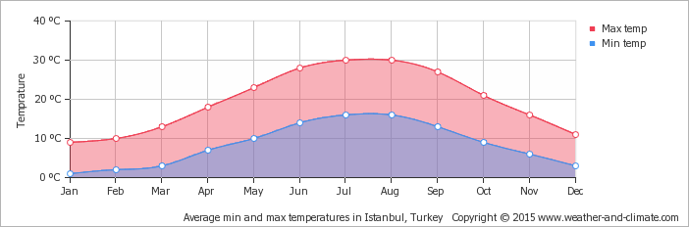
Autumn: Temperatures do not decrease rapidly, in September and October you can still enjoy good weather most of days. Cloudy days or light rains are common and maybe you can consider a jacket for nights. In early November, the temperatures start to fall significantly but it’s early for storms or snow.
Winter: Starting from December till March temperatures are around 5-10' C. Although it’s not common for Istanbul, get prepared for (-) degrees C in some days. Snow and strong winds negatively affect city transportation especially ferries. People prefer shopping malls or covered areas in this season except New Year's Eve. Unluckily it didn't snow for plenty of years on that day but there are streets parties on that day forgetting cold weather.
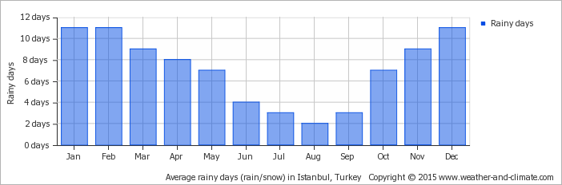

6. Shopping Places/Hours
As home of The Grand Bazaar the world’s largest covered markets in the world with more than 58 streets and 4,000 shops, Istanbul World’s only Metropolis on Two Continents does not only maintains the monumental state of the bazaar, but also makes it a palace for shopping. Besides open bazaars like Grand and Spice Bazaar, there are many gorgeous streets like İstiklal and Bağdat Street. Moreover almost every neighbourhood has at least one mall of which ae very popular like Mall of Istanbul, İstinye Park, Ak Merkez and so on. They are open between 10 am and 10 pm.
7. Hospitals/Drug Stores
Drug stores are usually open from 9:00 to 19:00 in the weekdays. At nights and at the weekends there are open stores in each neighbourhood for emergency situations that may occur. This open establishment can be found online or in each pharmacy’s billboards.

8. Cultural Activities
There are many opportunities to participate in cultural events and activities in YTU. There are symposiums, forums and many other formal events. Apart from these formal events there are also a lot of events that are organized by school’s clubs. There are cinema nights, many sightseeing tours, theatre activities in which you can participate to star in a play or simply improving your acting skills.
You can also find many events in İstanbul as well as many places to visit.
http://www.ibb.gov.tr/sites/ks/en-us/Pages/Home.aspx
http://www.timeoutistanbul.com/en/

9. Miscellaneous Costs
Bus 2.30 (1,15 with student card)
Cinema 12 (may change on holidays, weekends etc...)
Lunch in University Canteen 2-5
Lunch in Fast Food Joints 10-15
Beer in a bar 5-10
Coke/ Beer bought from supermarket 3-4

C. Academic Issues

1- Before the Mobility
For traineeship mobility between 1st June N and 30th September N+1, any duration on condition that not to be fewer than two months, is possible as long as you have applied to your university first for Erasmus+ Traineeship Mobility.
As long as you have been found eligible for Erasmus+ Traineeship Mobility by sending university, you can proceed with the below procedures of Yıldız Technical University.

- Please contact the relevant department that you wish to work in directly so as to see if they are interested in an exchange student as a trainee.

Please check;
For the academic units http://www.bologna.yildiz.edu.tr/index.php?r=academicunit/index
For the departmental Erasmus coordinators http://www.eu.yildiz.edu.tr/en/sayfa/8/Departmental-Coordinators/177

- Accordingly, find a mentor and discuss what the traineeship might involve.
- Send your “Application form” and “Learning agreement for traineeship” to erasmus-staj@yildiz.edu.tr .
- You will be sent a “Letter of Acceptance” so that you can go on with the visa procedures.
- Photo (headshot in jpg format)
- Following your application and checking your documents, you will be sent a confirmation e-mail including your Letter of Acceptance.

Check the links for the details;
Documents: http://www.eu.yildiz.edu.tr/en/sayfa/5/Student-Traineeship-Mobility/164
General info: http://www.eu.yildiz.edu.tr/en/sayfa/1/Traineeship/161
Practical info: http://www.eu.yildiz.edu.tr/en/sayfa/8/Incoming-Students-Traineeship-Mobility/183

2- During the Mobility
The students accepted for a traineeship period, are responsible for fulfilling the tasks agreed on the Learning agreement.
In case of any change on the tasks, dates or responsible persons, the students should inform the EU office and prepare the document of Changes.

3- After Mobility
When the mobility has been completed, a traineeship certificate is prepared and signed by the mentor and sent to EU office for official confirmation. The students are supposed to get the traineeship certificate from the EU office. It is highly advised for the students to remind their mentor to prepare the certificate before departure. Moreover, if the students have other documents to be signed, belonging to their home university, they should also bring the documents to EU office.

D. Reminders
- Note that you will be informed for all announcement via e-mail so please provide a valid e-mail address to EU Office on the documents you submit and as soon as you have a mobile number from a GSM operator in Turkey and a permanent accomodation, share your mobile number and address with EU Office.
- Note that all of documents need to be the latest version which can be downloaded from http://www.eu.yildiz.edu.tr/en/sayfa/5/Student-Traineeship-Mobility/164 and filled out electronically (no handwriting).
- Remember that YTU, unfortunately, cannot provide accommodation, any kind of insurance and payment. You can contact with ESN club for these issues.
- It is highly recommended that your traineeship period will be not more than 90 days since you will be exposed to a long and tiring procedure of residence permit.
- Please keep in mind that documents are signed at most in 3 workdays, so you may not receive the documents you left for signature on the very same day.
- If there is a «home university» section on the signature page of any document, please have the document signed by your home institution first; then, have it signed by your departmental coordinator at YTU, and finally submit it to EU Office for official signatures and stamp.

E. EU Office Hours
Monday | Tuesday | Wednesday | Thursday | Friday
10:00  12:00 | 14:00  16:00 | 10:00  12:00 | 14:00  16:00 | 10:00  12:00

If you want to meet with an office representative outside of office hours, please ask for an appointment through e-mail.
If you need any further information and assistance, please contact with Erasmus Office.
YTU Erasmus Office
Erasmus+ Traineeship Department
E-mail : erasmus-staj@yildiz.edu.tr
Phone : +90 212 383 5654
Address : Yıldız Teknik Üniversitesi, Avrupa Birliği Ofisi
Davutpaşa Kampüsü, Taşkışla Binası A-1003
34220 Esenler / İSTANBUL

F. Useful links
Yıldız Technical University: http://www.yildiz.edu.tr/
EU Office http://www.eu.yildiz.edu.tr/
YILDIZ-TÖMER: http://www.tomer.yildiz.edu.tr/eu/
İstanbul Municipality: http://www.ibb.gov.tr/tr-TR/Pages/AnaSayfa.aspx
List of Consulates and Contacts: http://www.mfa.gov.tr/fahri-konsolosluklar.tr.mfa

G. Useful numbers
Fire Brigade- İtfaiye: 110
Police-Polis: 155
Emergency service-Acil Yardım: 112

